Chapter 13, Problem 22.

Find current I_{o} in the circuit of Fig. 13.91.

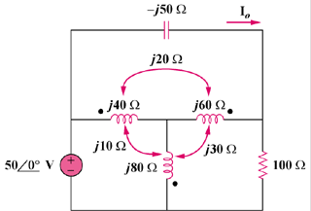

Figure 13.91
For Prob. 13.22.

